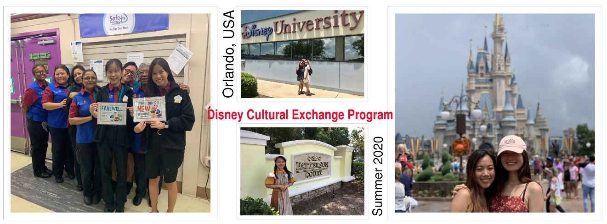

Before Making an Application (2020 intake)
If you are interested in applying for Disney Cultural Exchange Program, then please check if you can meet the following requirements:
- Be a full-time undergraduate non-final year student in Lingnan University, i.e. Yr. 1 up to Yr. 3 students are eligible
- At least be 18 years of age
- Have good conversational English
- Be willing to share living quarters with other participants
- Have an outgoing, enthusiastic, and people-oriented personality
- Be hardworking, independent & mature
- Have a fun-loving & cheerful character
- Have good manners & good grooming
- Have a flexible and responsible work attitude
- Academic status in good standing
- Have good attitude and committed to complete the FULL working period as specified by Disney ICP
*** Students being offered a place in this Program must undergo all required training in October/November 2019, Feb/Mar 2020 and May 2020; plus a debriefing in Sep 2020 in order to be entitled for receiving the subsidy* from the University.
Note 1: Students are advised to think thoroughly whether you are suitable to work outdoors in a very hot environment, or be able to stand for very long hours. Please take into consideration your own health conditions too. Consider whether you are independent and mature enough to take care of yourself without relying on others to take care of you. You shall also consider your financial ability to support yourself living in the US for 2 months, plus to pay for all the required expenses. SSC subsidy of HK$8,000 will not be able to support all your expenses for this programme.
* Subsidy of HK$8,000 will be eligible for students from UGC-funded undergraduate degree programmes only.
Note 2: Those who are considering applying for the academic exchange program (Aug/Sep 2020 intake) to the USA or other foreign countries are advised to check with the OGEIS the exact departure date (from HK to the location of the exchange institution) and your exchange visa processing time. If the departure date clashes with the end date of Disney Program, you are advised NOT TO APPLY for the Disney program as you will be unable to complete the full work period – which is a violation of your agreement with the employer. The employer reserves the right to blacklist you for future employment with the Disney Group.
Note 3: To follow Note 2, if you need extra time to apply for your academic exchange visa, you shall plan properly and make sure you have enough time to get your exchange visa processed. No one shall be responsible for your delay or missing of any important dates of your exchange program because of your own miscalculation and carelessness.
Note 4: Due to visa complication, students who ARE NOT IN HONG KONG during the 2nd term of 2019-20 academic year, have a relatively lower priority of getting selected for the 2020 summer Disney CE program.

Application Method (for 2020 intake) – application deadline on 2 Oct 2019 (Wed) at 5:00pm
- Please complete the Disney Cultural Exchange Application form for Lingnan students.
- Please submit a ONE-page resume/CV together with your application.
- Submit a copy of your recent photo - in business attire. Attach this with your application.
- Submit a copy of your University web transcript where your GPA is shown. Yr 1 students are not required to submit this.
- Submit a copy of your passport. If you don't have a passport, then submit HKID copy.
By the 1st week of November, you are required to have a valid passport for travelling. That also means, if your passport is going to expire by end of December 2020 or before, you must submit an application for renewing your passport by 1st week of November 2019. Or else, you will risk having your application/nomination being cancelled by Disney.
- Book your group interview appointment with SSC staff.
* SSC will not process applications with missing documents. You will not be allowed to attend the screening interviews on 8 Oct 2019 if your application is incomplete.

Application Process & 2019-20 Schedule (For reference only)
23 Sep 2019 | Disney Information Session
2 Oct 2019 @5:00pm | Application deadline
8 Oct 2019 (Tue) | Internal selection group interview
9-10 Oct 2019 | Announcement of results and acceptance of nomination
14 Oct 2019 (Mon) &  4 Nov 2019 (Mon) | Pre-Interview Training and Preparation – 2 sessions
19 Nov 2019 (Tue) | Campus Final Interview with Disney rep in Hong Kong
Mid-Dec 2019 | Confirm offer
End of Feb 2020 (tentative) | Briefing session for US visa, Travel and Accommodation arrangement
After final exam in May 2020 | Pre-departure briefing / training
Jun 2020 (To be updated) | Departure for Program
1 st week of Sep 2020 | De-briefing & Evaluation

** All the above training and debriefing schedules are COMPULSORY to selected candidates.

